**Essay Draft Deliverable:**

**Optimal Battle Strategy for Fate/Grand Order**

**Summary:**

Fate/Grand Order or FGO, is one of the most popular mobile games around the world. It is a turn-based game, where you the Master (which is what I will be calling the players), roll (open loot boxes) for a chance to get a Servant, which are the units which you will make your party with during battles. We will not be talking about on the best strategy on how to roll for highest tier Servants (Since this process is all about luck), but on how to efficiently use Servants during battle. In FGO, there are 13 unique Servant class Affinities, each with their own effective/resistances to other classes. The propositions and constraints that I will be highlighting in this essay will be of the player during battle. A lot of people struggle on what Servants they must bring to battles so in this essay I will be outlining the optimal strategy with the units that they have.

**Propositions:**

Like I said above, the propositions and constraints will take place during a battle in FGO.

* Si,a: is true when the Master’s servant is in position ‘i’ between 1-3 and ‘a’ is class affinity (Saber, Archer, Lancer, etc…)
* Oi,a: is true when an opponent is in position ‘i’ and is class affinity ‘a’
* A: is true if ally Servant declares an attack
* D: is true if opponent is damaged
* E: is true if an attack is Effective against opponent (Does most amount of damage)
* R: is true if an attack is Resisted by opponent (does minimal damage)
* N: true if an attack does neutral damage
* F: is true for servants on the field
* Ct: is true if it is a sequence of three attacks that can be chosen during the Master’s turn number ‘t’

**Constraints:**

A Master’s Servants and enemies cannot be more than one class affinity:

­­­­­­­­¬ ( S1,Saber^ S1,Avenger ) ∧ ¬ ( E1,Alterego ^ E1,Berserker )

There can only be max three ally Servants and max three enemies on the field at once.

F → ( ( S1,a^ …^ S2 or 3,a ) ^ ( O1,a ^ … ^ O2 or 3,a ) )

For depicting constraints for effective, resistant, and neutral attacks we will consider the below: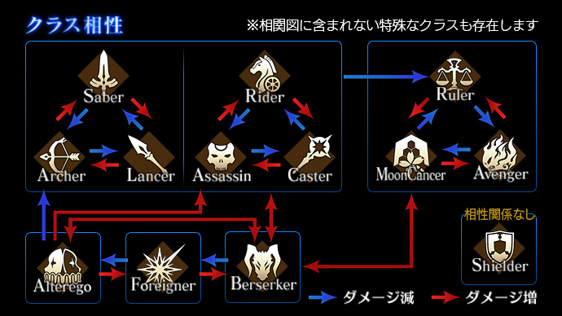

Effective and Resistant attacks:

Effective Attacks:

( ( Si,Saber ^ A ) ^ ( ( Oi,Lancer ^ D) v ( Oi,Berserker ^ D) ) ) → E

( ( Si,Berserker ^ A) ^ ( Oi,Berserker ^ D) ) → E

Etc…

Resistant Attacks:

( ( Si,Berserker ^ A) ^ ( Oi,Foreigner ^ D) ) → R

Etc…

Neutral Attacks: (Shielder neutral to all classes, classes neutral to same class except

berserker)

( ( Si,Saber ^ A ) ^ ( Oi,Saber ^ D ) ) → N

Etc…

Sequence of attacks (Choose how you want to attack, e.g., all party members attack, one member does two attacks and another does one, one attacks three times, etc…):

In this example of a party of F → ( ( S1,Saber^ S2,Ruler ^ S3,Berserker ) ):

Ct → ( ( S1,Saber ^ A ) ^ ( S1,Saber ^ A ) ^ ( S1,Saber ^ A ) ) or

Ct → ( ( S1,Saber ^ A ) ^ ( S3,Berserker ^ A ) ^ ( S1,Saber ^ A ) ) or

Ct → ( ( S1,Saber ^ A ) ^ ( S2,Ruler ^ A ) ^ ( S3,berserker ^ A ) )

Then we have something like this:

Ct ^ ( Oi,a ^ D)

**Limitations:**

The main aspect that my model does not cover is the during the sequence of attacks, we only attack one of the enemy units. In the game’s battle system, when an enemy is defeated, and the next attack is not of the Servant that defeated the enemy, then the next enemy in line will be attacked by the remaining attacks left in the sequence. If an ally servant has let’s say all three attacks in the sequence, then it will keep on attacking the same enemy even if it is defeated by one of its previous attacks in the sequence. This was not included in the constraints and propositions since it would be very complicated to model even if I added more propositions.